|  |
| --- |
| **TRAPEZOIDAL RULE** |

Directions: Approximate the area under the curve over the given interval using 5 trapezoids.

1.) $y=-x^{2}-2x+9$ $\left[-3, 2\right]$ $n=5$

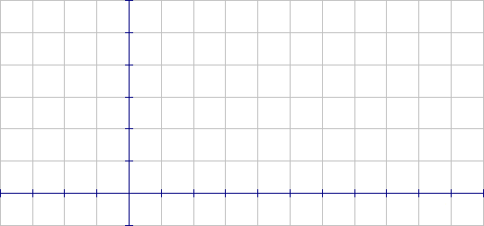

2.) $y=\frac{2}{x}$ $\left[2, 7\right]$ $n=5$



Directions: Approximate the area under the curve over the given interval using 3 trapezoids.

3.) $y=-\frac{x^{2}}{2}+x+5$ $\left[0, 3\right]$ $n=3$



4.) $y=\frac{x^{2}}{2}+x+1$ $\left[-2, 1\right]$ $n=3$

